Grade 7 Accelerated · Unit 4 · Lesson 1  Adding and Subtracting in Scientific Notation  Question Bank 4.01 | Name______________________  Date______________________  Period____________________

Show your work. Circle your final answer.
For questions 1 through 6, add or subtract. Write each answer in scientific notation.
1. 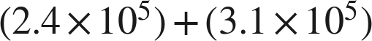

2.

3. 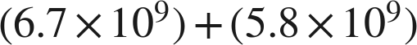

4. 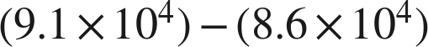

5. 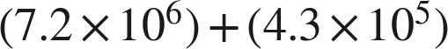

6.

Real quantities.
7. Neptune's diameter is about  kilometers. Saturn's is about 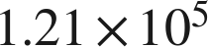 kilometers.
a. What is the sum of the two diameters?

b. Jupiter's diameter is about 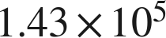 kilometers. Is your answer to part (a) greater than Jupiter's diameter?

8. A city's population is about 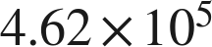. The surrounding county's population is about 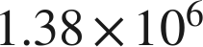.
a. What is the total population of the city and the county?

b. How many more people live in the county than in the city?

Working backwards.
9. Find the missing number in each equation.
a.

b.

c. 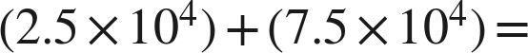 ______

Reading someone else's work.
10. Priya writes . Name the two mistakes she made, and give the correct sum.

11. Which is the value of , written in scientific notation?
○ A. 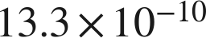
○ B. 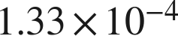
○ C. 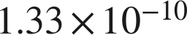
○ D. 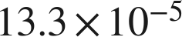

12. Select ALL of the expressions whose value is 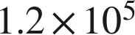.
□ A. 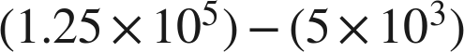
□ B. 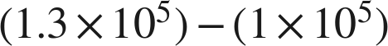
□ C. 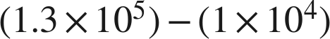
□ D. 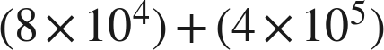
□ E. 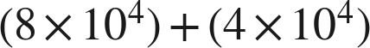
□ F. 